**1st Year Electronics Lab Spring Term**

**BEFORE THE LABS: The Bipolar Transistor and Some Important Characteristics**

¬ Refer to the data sheet (BC547B), and by tracing back the curves of collector current in Appendix: Datasheet, Figure 1 (in the saturation region), estimate the Early voltage for the NPN transistor as the point where they intercept the x-axis. Refer to the lecture notes if you are unsure.

Early voltage = -55V (In the range of -50 to -100)

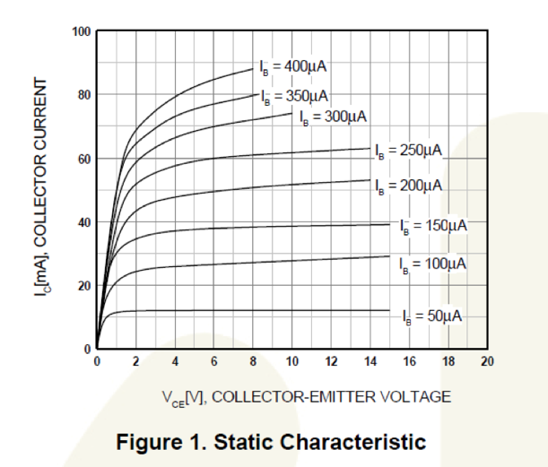

¬ From the data sheet (BC547B), find (and make a note of!) typical values of β (*hFE*) for the device operating with a collector current of 2 mA, a collector emitter voltage VCE of 5V and at a temperature of about 25°C. Note the very wide spread of values!

Β = 200

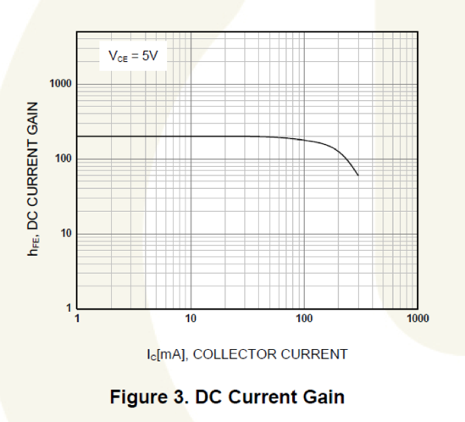



**SESSION 1: Characterizing the Device**

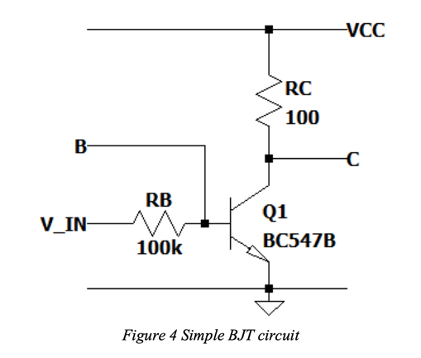

* ¬  Estimate the required value of V_IN to drive 20μA of base current, and double check your estimation by measuring the voltage drop across RB with your DMM. Tweak V_IN until IB=20 μA. Hint: when the BJT is in the active or saturation mode, what is the voltage across VBE?
* ¬  Now that the base current is set, we can start ramping up VCC from 0 to 10V, making a note of: o The voltage drop across RC (to find IC)  
  o Thecollector-emittervoltage

o VCC

* ¬  Repeat the previous points for the other two values of base current.
* ¬ Try to estimate the early voltage VA of the device using the data you have just gathered (ꝏ is not accepted as an answer!). How does it compare to the value you estimated from the datasheet?

**SESSIONS 2 and 3: Common Emitter (CE) Amplifiers**

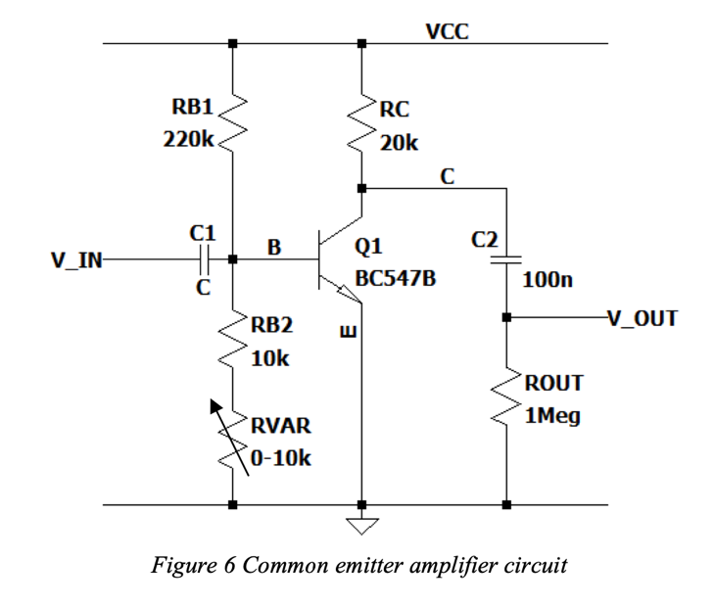 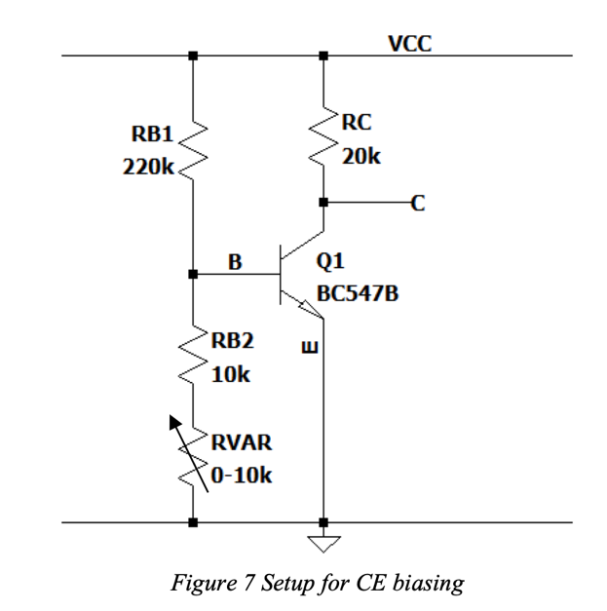

**Biasing the circuit**

Our general aim therefore is to place the quiescent operating point (i.e. when V_IN is open circiut) such that VC =VCC/2. Using a single rail supply (VCC=10V and emitter node E to GND) we can bias the output of the amplifier at a quiescent voltage of about 5V. Thus 5V will be dropped across resistor RC, so chose RC = 20k to get 0.25mA of quiescent collector bias current.

* ¬  For the circuit of *Figure 7*, Given the values of RB1 and RB2, estimate an expected value for RVAR to bias your CE amplifier around a quiescent output voltage of 5V. This depends on the actual β of your transistor, the chosen collector current and... temperature!

PS: You have already found in SESSION 1 a typical value of β for Ic = 2mA, from the data sheet. In this case β should still be close to that value.

*Expected value for RVAR:5469.6ohm*

*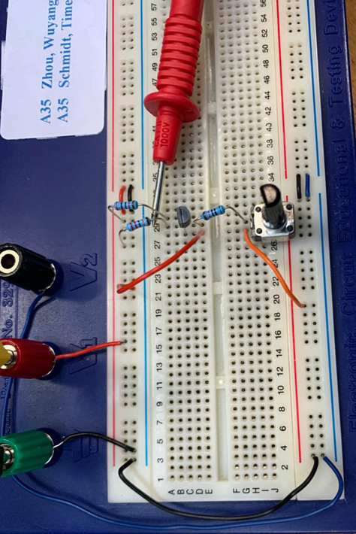The circuit in Figure 7*

* ¬  You can now build the circuit in *Figure 7*, using the given variable resistor for RVAR.
* ¬  Set VCC at 10 V and twist RVAR until the voltage at the collector terminal is exactly 5V.
* ¬  Measure the RVAR resistance and compare it to your original estimation.

*Actual RVAR value: 3850ohm*

* ¬ Make modifications to your circuit to obtain what is shown in *Figure 6*.

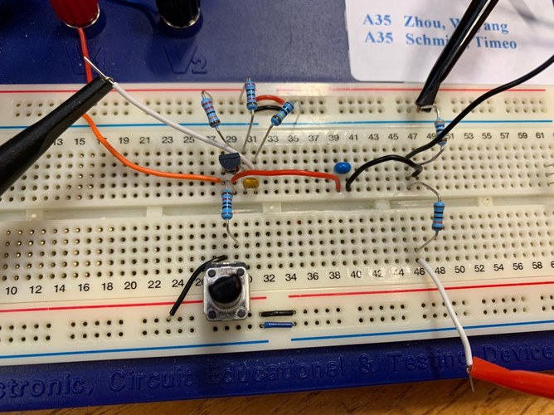 *The circuit in Figure 6*

* Note that the emitter of Q1 is at 0, so the base voltage cannot exceed 0.7V. Make sure that any external connection to the base is AC coupled through C1, otherwise you risk injecting a DC voltage higher than 0.7V into the base. Use a ceramic capacitor for C1 in a range of 100 nF to 470 nF. Since capacitor C1 is a DC blocking capacitor preventing input signals from affecting the bias levels, then the base current of Q1 is simply set by RB1 and the combination of RB2 plus RVAR.
* Now that the circuit is properly biased let’s test how sensitive it is to temperature changes: carefully hold the transistor’s plastic package between your fingers (without removing any of the connections!). Observe how the collector voltage changes. Make a note of the minimum collector voltage you achieve. Can you explain why this happens?

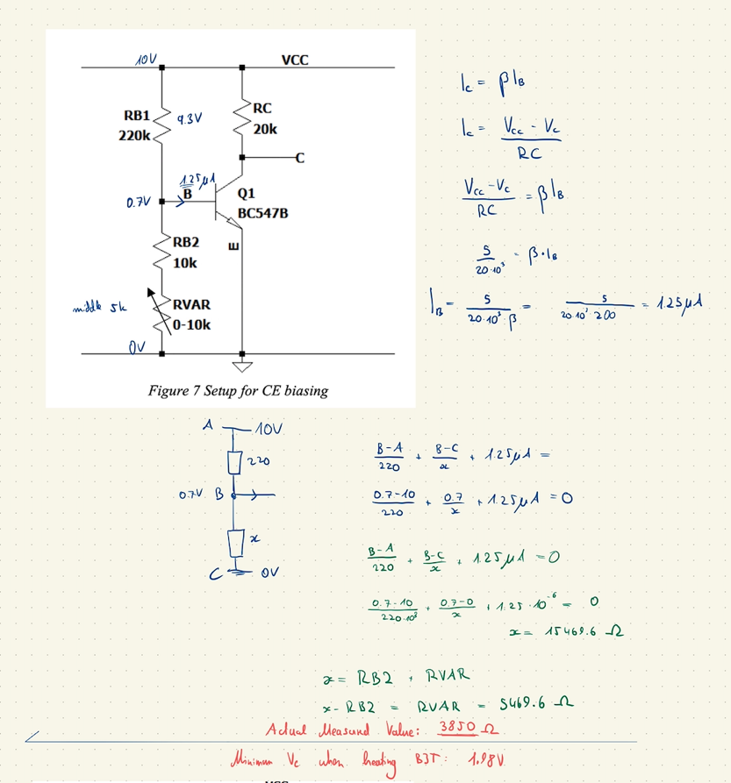The minimum collector voltage we achieved when heating BJT is 1.98V.

* ¬  Using the signal generator in your scope, produce a 1 kHz, 6 mV p-p triangle wave as your VIN and measure VOUT. (If the oscilloscope’s signal generator cannot reach the desired low-amplitude value set up a potential divider to achieve it, as we discussed before).

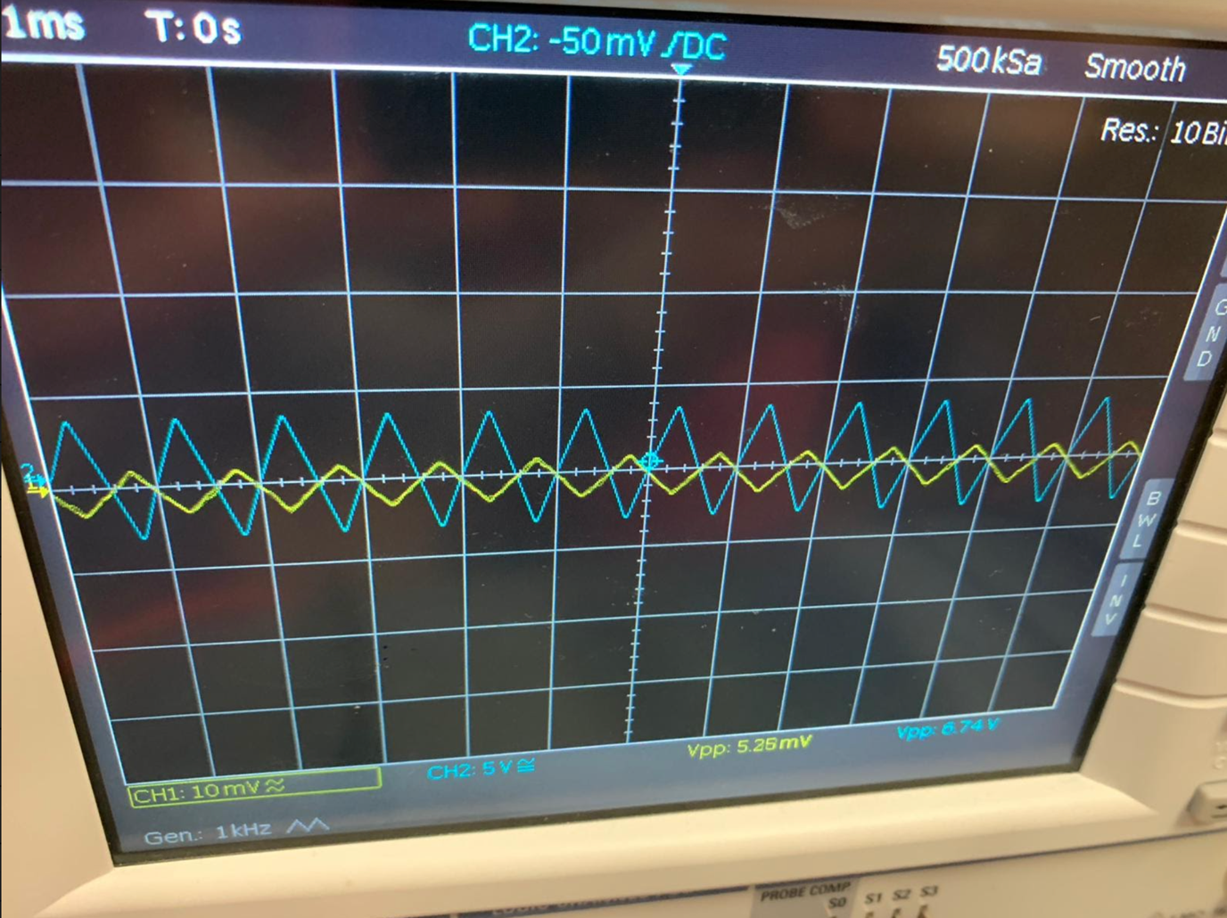

* ¬  Ramp up the VIN amplitude until your VOUT shows **distortion\***. Record the traces of the distorted and non-distorted output and give qualitative comments, providing an explanation of what you observe. Try to retake this same measurement when you move slightly above and slightly below your biasing point of VC = 5V (DC) by adjusting RVAR. 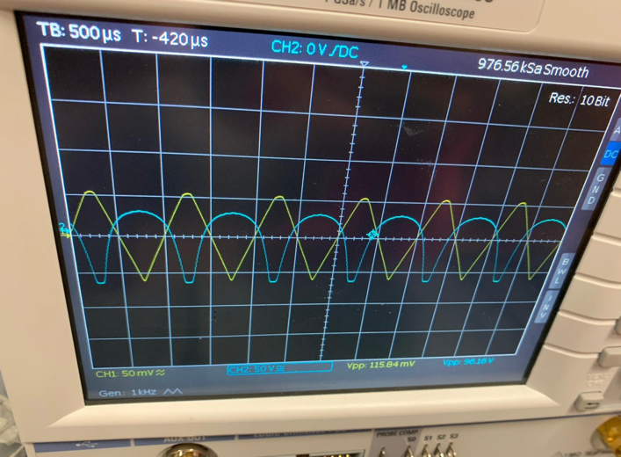

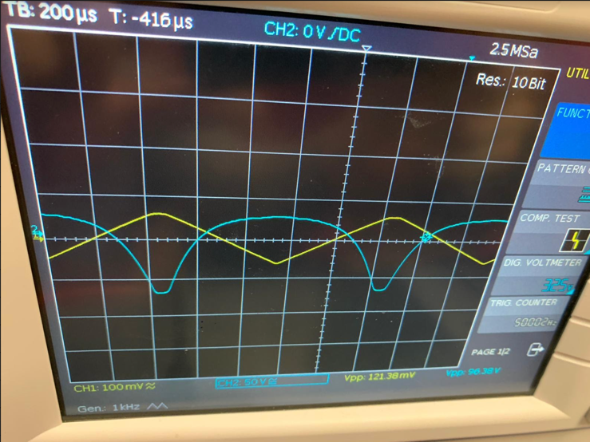

* ¬  Now change your input to a 1kHz 6mV p-p sine wave and find your AC voltage gain Av=ΔVOUT/ΔVIN. Make sure the output is not distorted. If it is, adjust your input voltage to a smaller value. Save your measurements.

*Av = 3.2/(6*10^-3) = 533*

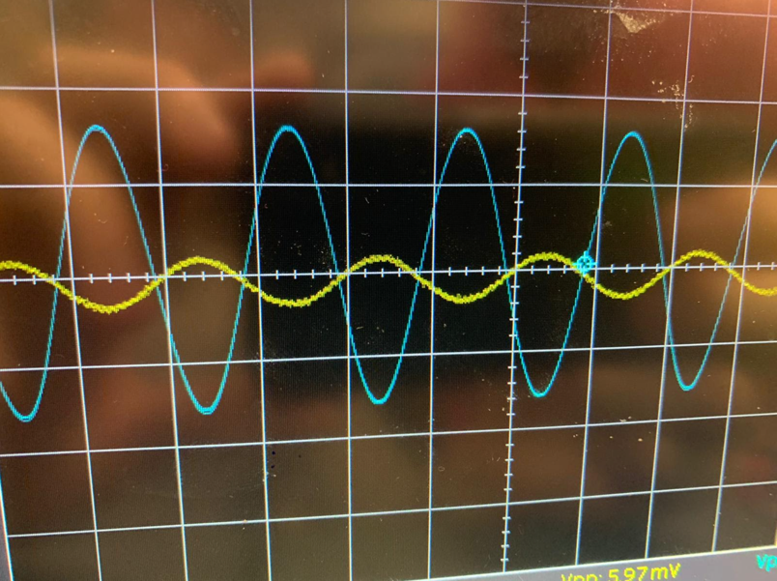

* ¬  What happens to VOUT if you set your input to a 1kHz 0.5V p-p sine wave?

Av= 8.13/(13.5*10^-3) = 602

Double check

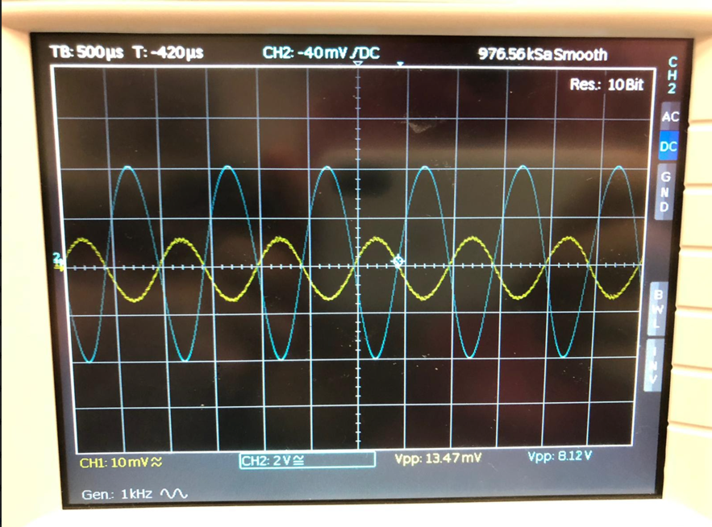

* ¬  Apply a sinewave input (same one used earlier such that the output is not distorted), and measure the output voltage amplitude of the amplifier, V_OUT, which we will call vout1.

Vout1= 8.12V

* ¬  Connect a 10kΩ resistor in series with the amplifier input. Measure the output voltage amplitude again – it should have decreased. Let’s call this value vout2. You can now compute the input resistance of your amplifier, since: vout1 = vout2 (1+10k/ Rin), where Rin is the input resistance of the amplifier. Can you derive this formula yourself?

Internal resistance:

**Emitter Degeneration**

An emitter resistor (*Figure 8*) introduces a form of negative feedback: when the emitter current changes due to thermal effect, the voltage drop across RE changes accordingly, pulling the base emitter voltage in the opposite direction. This helps stabilizing IE to its original value, rejecting its change, and is called *emitter degeneration*.

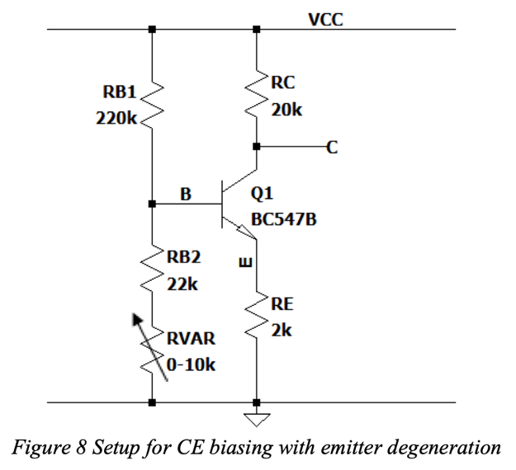

* Modify your circuit to obtain the circuit shown in *Figure 8*.
* Similarly, to the previous parts, estimate a value of RVAR and tweak the variable resistor until you obtain a collector voltage of 5V. Is this close to your estimation?
* Test how much the collector voltage can drift from its biasing point due to temperature changes (same “touch-test” performed earlier) and record your findings. Explain what you observe.

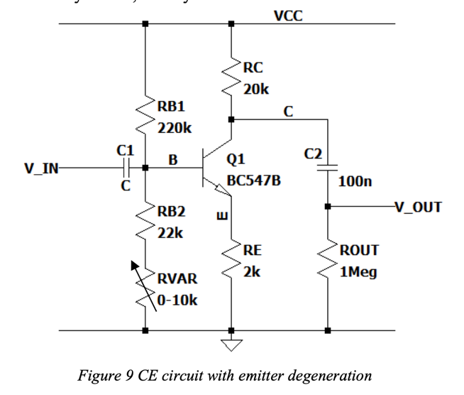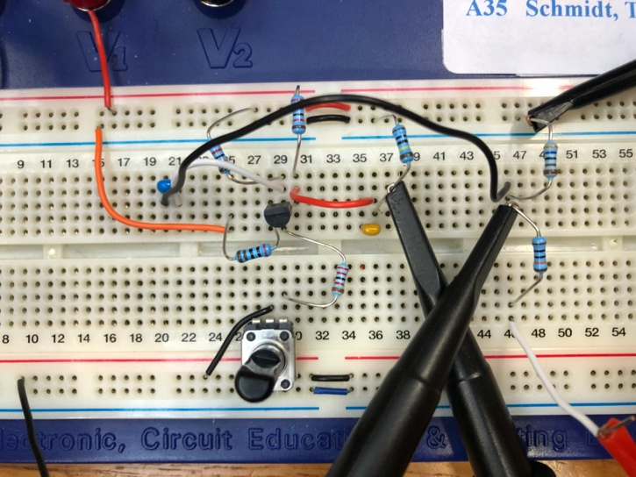

* ¬  Using the signal generator in your scope, produce a 1 kHz, 6 mV p-p triangle wave as your V_IN and measure V_OUT. (If the oscilloscope cannot reach the desired value set up a potential divider to achieve it).

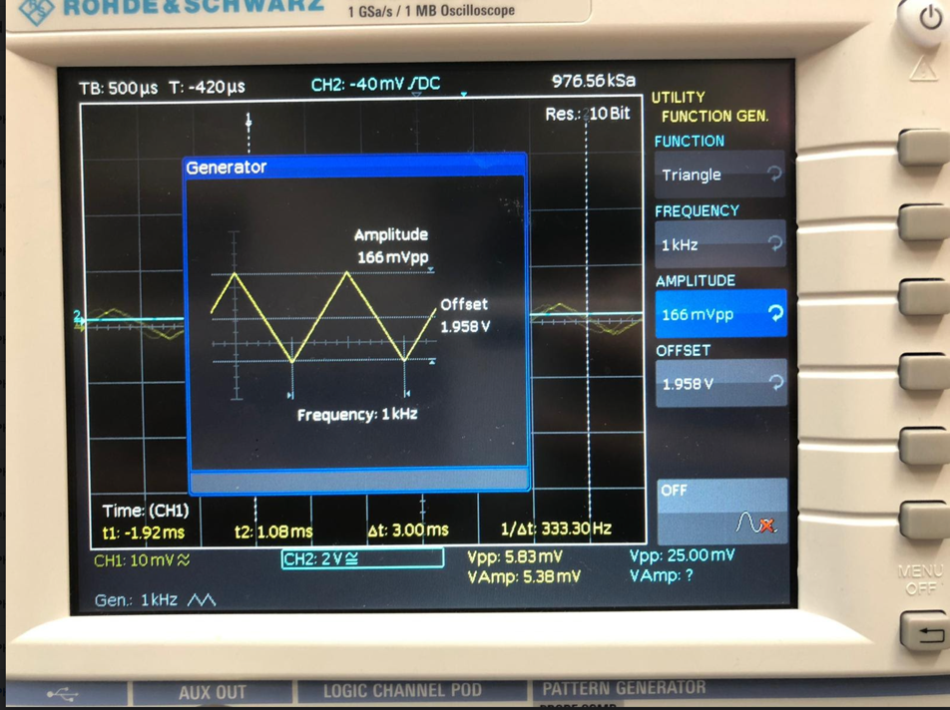

Vout = 42.07mV

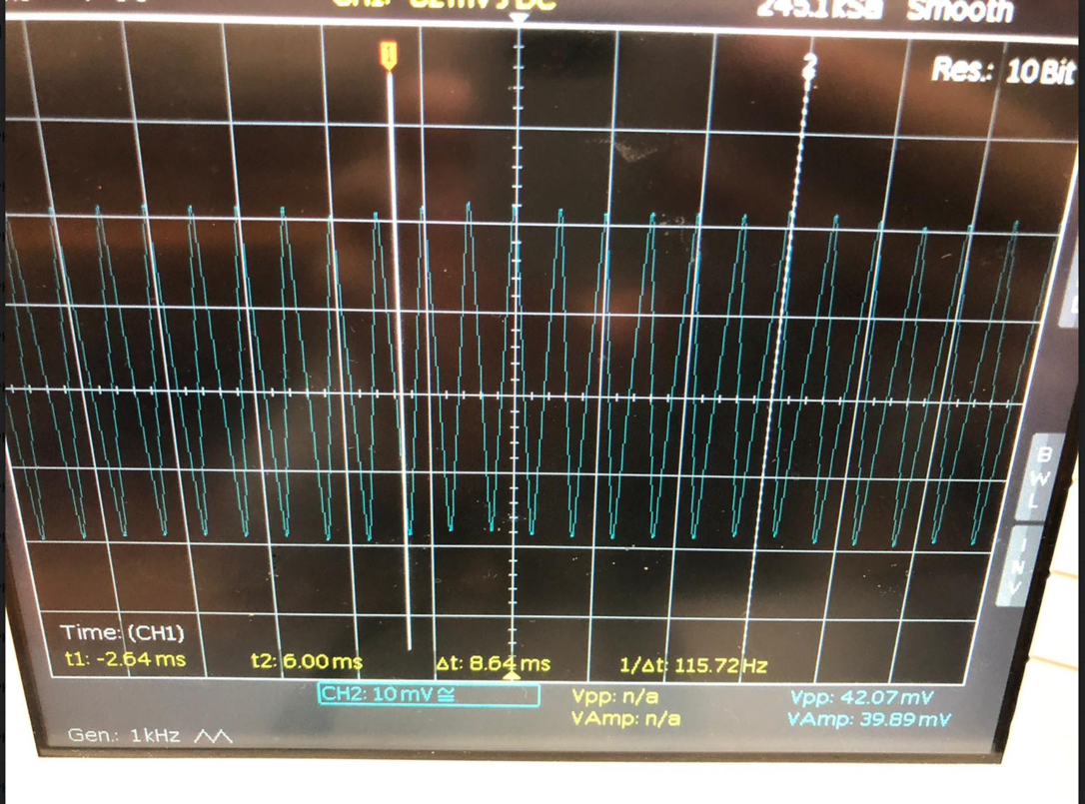

* ¬  Ramp up the V_IN amplitude until your V_OUT reaches distortion. Record the traces of the distorted and non-distorted output and give qualitative comments, providing an explanation of what you observe.

*There is clipping in V_OUT.*

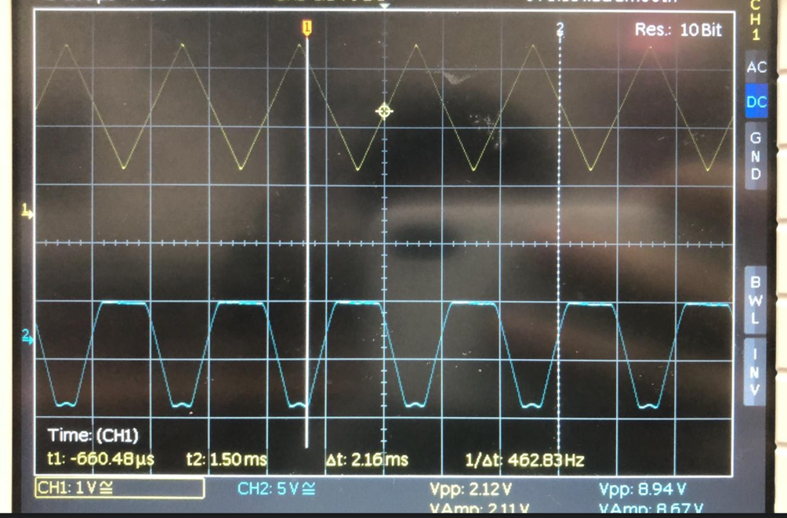

* ¬  Now change your input to a 1 kHz, 6 mV p-p sine wave and find your AC voltage gain Av=ΔV_OUT/ΔV_IN. Make sure the output is not distorted. If it is, adjust your input voltage. Save your measurements.

How does the emitter degeneration CE amplifier compare to your previous circuit?

Smaller gain, harder to distort.

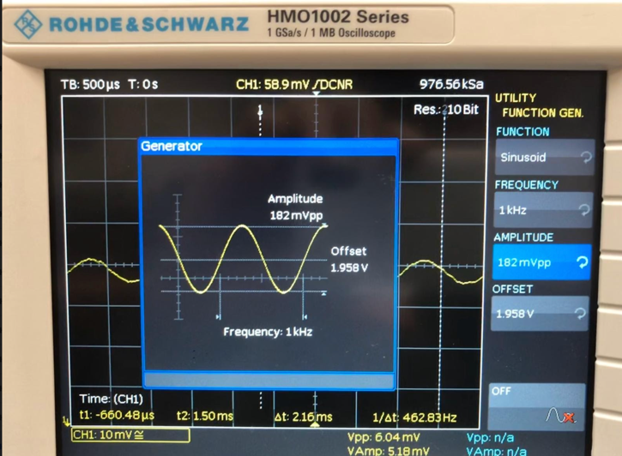Av = 50.88 / 5.92 = 8.60

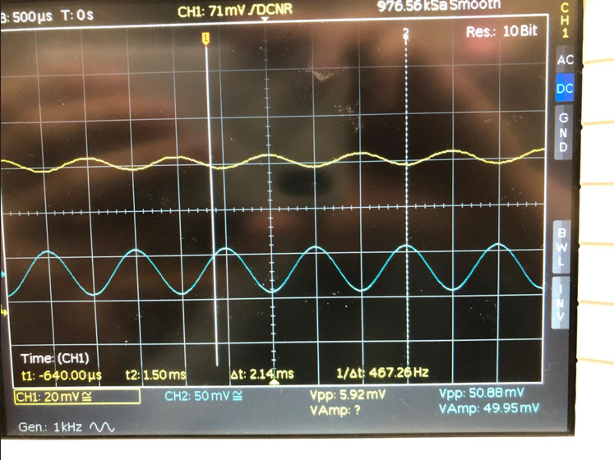

¬ Now add the capacitor C3 as shown in *Figure 10* and retake the measurements for Av. What do you notice?

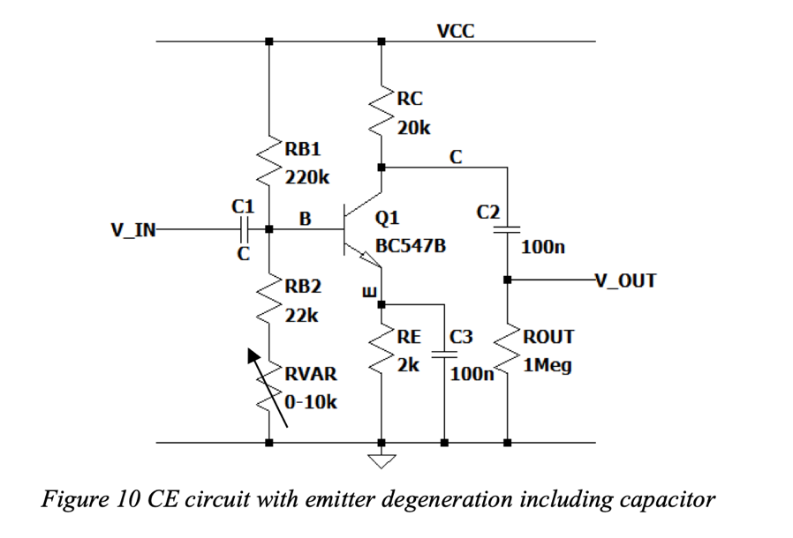

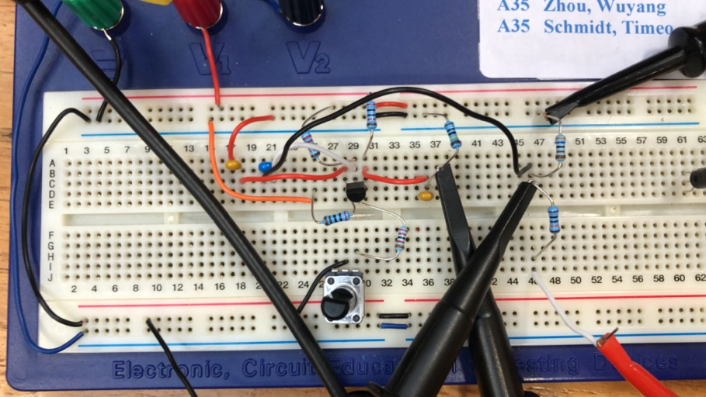

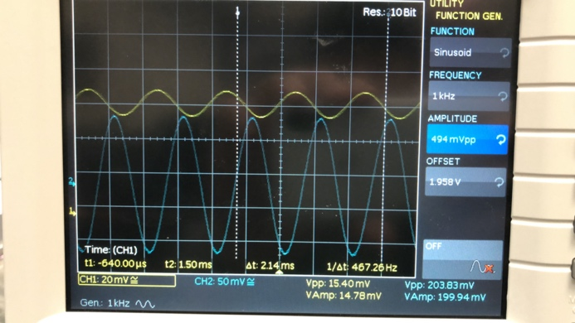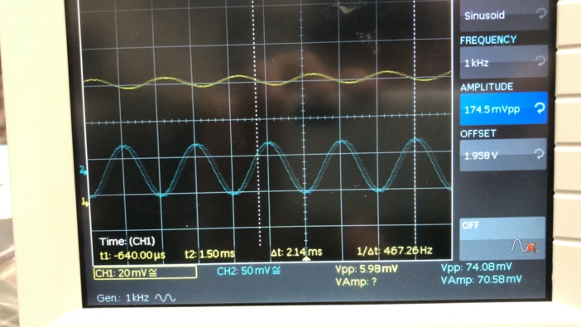

**Free Optimization of a different configuration of CE amplifier**

This part of the lab is less prescriptive and more open-ended. You are given the circuit in *Figure 11* which uses yet another type of biasing scheme, deriving the bias voltage from the collector of the BJT. Using the techniques learnt in this lab:

* ¬  Simulate the circuit in LTSpice (or build it if you like.... but simulation should be faster....)
* ¬  Measure the AC gain.
* ¬  Investigate how stable the amplifier bias point is with temperature (in LTSpice, you can change the

temperature of the simulation with a SPICE directive, i.e. “.TEMP 40” would set the temperature of

the circuit to 40 oC.)

* ¬  Investigate the relation between power consumption of your amplifier and its AC gain.

